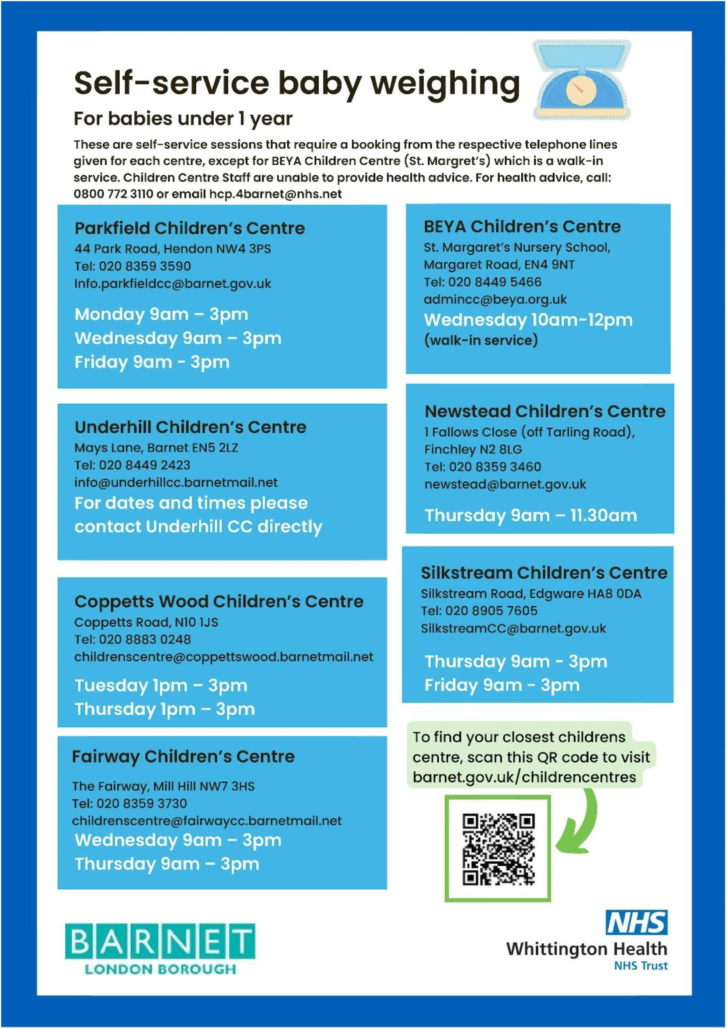

**Thursday 1pm – 4pm**

**For dates and times please contact Underhill directly**

**Underhill Children’s Centre**

Mays Lane, Barnet EN5 2LZ

Tel: 020 8449 2423

info@underhillcc.barnetmail.net

**Monday 1.15pm – 2.15pm Walk in service**

**Friday 1.15pm – 2.15pm Walk in service**

**Tuesday 2pm – 3pm Term time**

**Wednesday 10am – 12pm**

**Walk in service**

**Newstead Children’s Centre**

1 Fallows Close (off Tarling Road),

Finchley N2 8LG

Tel: 020 8359 3460

Childandfamilyhub-eastcentral@barnet.gov.uk

**BEYA Children’s Centre**

St. Margaret’s Nursery School,

Margaret Road, EN4 9NT

Tel: 020 8449 5466

admincc@beya.org.uk

**Wednesday 9am – 3pm**

**Thursday 9am – 3pm**

**Fairway Children’s Centre**

The Fairway, Mill Hill NW7 3HS

Tel: 020 8359 3730

childrenscentre@faiwaycc.barnetmail.net

**Thursday 9am – 3pm**

**Friday 9am – 3pm**

**Silkstream Children’s Centre**

Silkstream Road, Edgware HA8 0DA

Tel: 020 8905 7605

SilkstreamCC@barnet.gov.uk

**Coppetts Wood Children’s Centre**

Coppetts Road, N10 1JS

Tel: 020 8883 0248

childrenscentre@coppettswood.barnetmail.net

**Parkfield Children’s Centre**

44 Park Road, Hendon NW4 3PS

Tel: 020 8359 3590

Childandfamilyhub-south@barnet.gov.uk

**Monday 9am – 3pm**

**Wednesday 9am – 3pm**

**Friday 9am – 3pm**